|  |  |  |  |  |  |
| --- | --- | --- | --- | --- | --- |
| Date | 30-Nov-22 | | | Tester Name | Mayuri Patel |
| Environment | Penfax - Test | | | Login used |  |
| Operating System | Select OS | Version: | Update: | | |
| Software Used | Select Software | Version: | Update: | | |
| Select Software | Version: | Update: | | |
| Release version | 22.4.1 | | | | |
| Title |  | | | | |
| Test Type | Regression | | | | |
| Test Scenario | Set up a 2nd Bank account for payments | | | | |
|  |  | | | | |
| Expected Results |  | | | | |
| Pass/Fail | Pass | | | JIRA# | N/A |

Describe your steps with screenshots:

Search a member to set up a second bank account for payment

Open that member Profile

Go to payment instruction under Person Profile

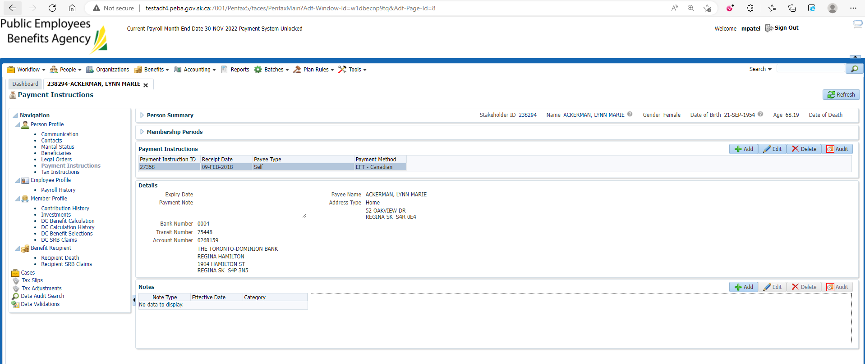

Add payment instruction

Enter mandatory details and Save

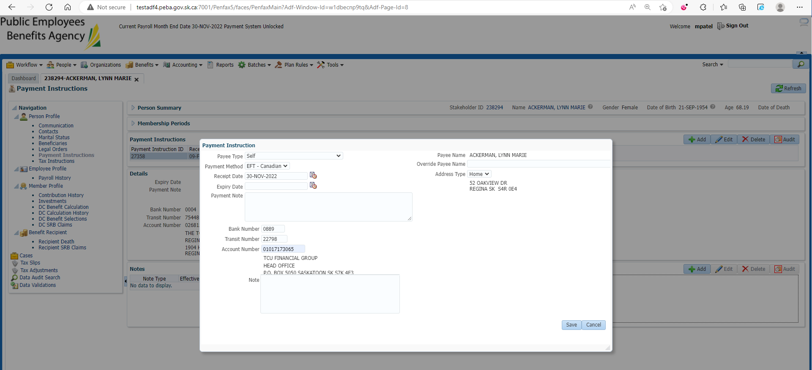

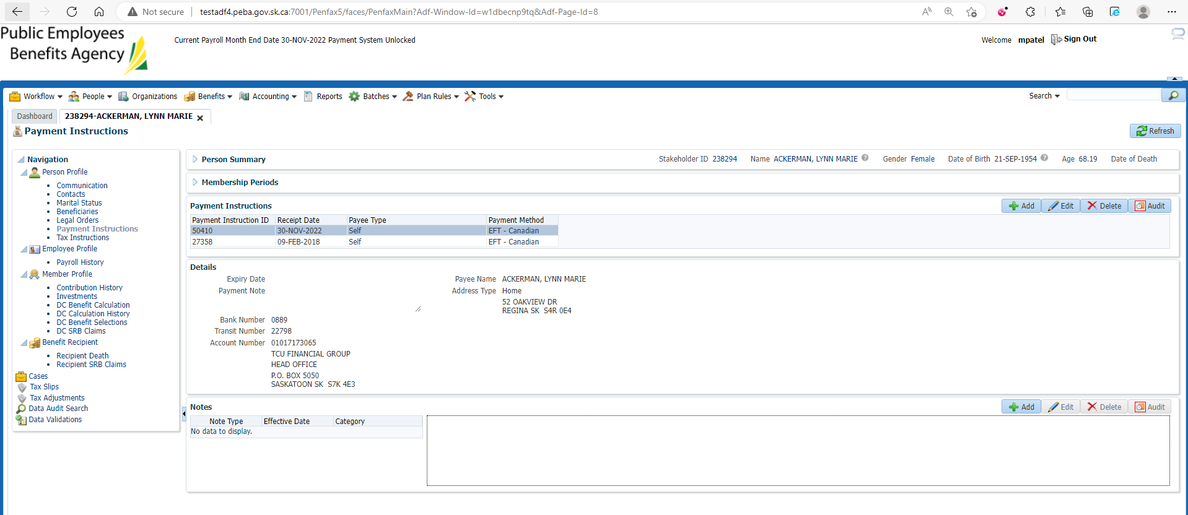

Go to Benefit recipient

Under Income benefit tab make sure old payment Instruction is there

